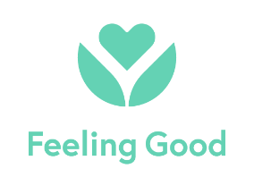
Information Sheet
Feeling Good App
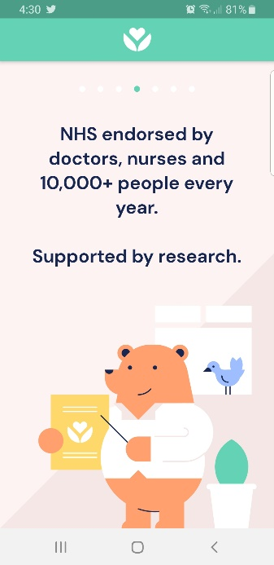
To overcome stress, low mood & worry
The Feeling Good App contains the evidence-based audio programme Feeling Good for Life, which is the new name for Positive Mental Training, a series of 12 audio tracks to help you build essential skills, not only to deal with mental stresses and strains, but to bounce forwards and become mentally stronger and more resilient. There are other modules on the app, all contain the same beginning tracks from Feeling Good for Life.

This programme can help relax & calm your mind and body, lift your mood, help you feel more positive, let go of worries, sleep better and deal with stresses more easily. It can also help with physical symptoms of stress, such as headaches, irritable bowel, fatigue, and chronic pain. It can improve your ability to focus on a task, to feel positive about yourself when talking to others, to perform at your best when you need to.
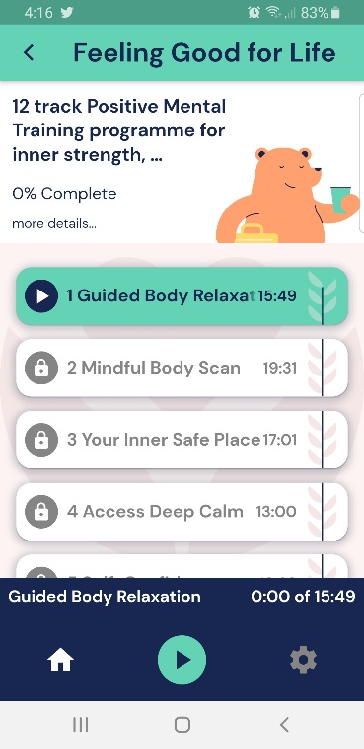
Start now: Find a place to make yourself comfortable and start listening to track 1 on Feeling Good for Life. You will be asked to close your eyes and relax, make sure you’re in a safe environment in case you fall asleep. It’s good to listen at least once a day, listening to the same track for a few days before moving onto the next track. There are 12 tracks in all but most people tell us their sleep & mood quickly improve.
For more info visit https://www.feelinggood.app for research and helpful videos
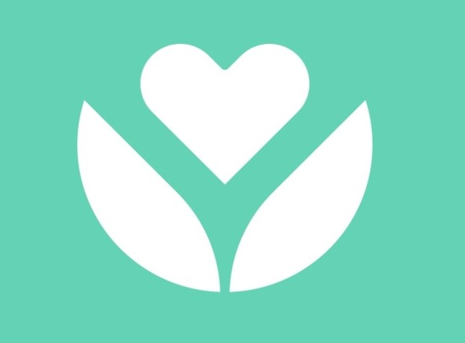
Get the app! Downloading the app is free
1. Visit your app store on your phone or tablet.
2. Search on ‘feeling good: mental fitness’ and look for the logo
3. Install the app free to your device. It comes with free stuff.
4. Unlock the rest of the tracks by putting in the referral username and password below into the referral section
5. Complete the questionnaire –helpful to us and you – all results are anonymous.
.
medwaypatient
positive
My in-app referral username My in-app referral password
Now Relax and Restore!
Medway South app info sheet

